**Saint Brigid St. John the Baptist**

31st Sunday in

Ordinary Time

November 4, 2018

**Catholic Church Catholic Church**

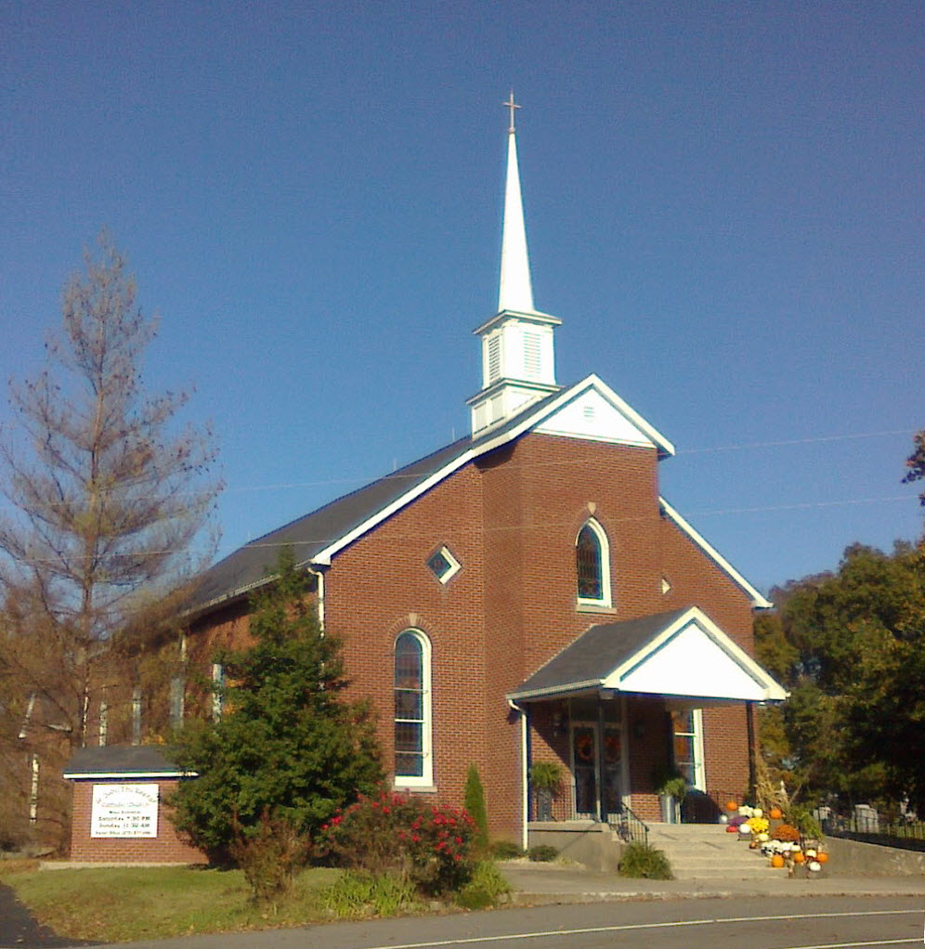

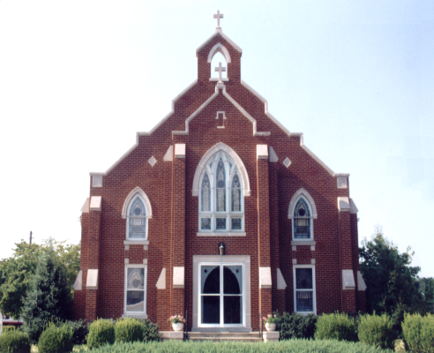

**Pastor:**

***Rev. Daniel L. Lincoln***

Rectory: (270) 877-2546

**Deacon:**

***Michael A. Ryan***

(270) 272-6789

314 E. Main St. 657 St. John Church Rd.

Vine Grove, KY 40175 Elizabethtown, KY 42701

Clustered Parish Office: Clustered Parish Office:

**ANNOINTING OF THE SICK:**

Notify the parish office when a family member is hospitalized.

**BAPTISM:**

Contact the parish office for information about the required preparation class.

**BULLETIN:**

Information must be submitted in writing by note or email to the parish office **no later than 4:00 p.m. on Tuesday** for the following weekend. When sending an email, please put “BULLETIN,” and the name of the parish the announcement is for, in the subject line.

**MARRIAGE:**

Contact Father at least 6 months prior to the wedding date to complete required marriage preparations and to schedule the date.

**RCIA (Rite of Christian Initiation of Adults):**

Contact the Worship Chairperson for information.

**DEW MEMORIAL LIBRARY:**

(in St. Brigid Church basement):

Open: Sunday after 9:30 a.m. Mass& 45 minutes before all other Masses.

(270) 877-2461 (270) 877-2461

Email: [brigidvg@bbtel.com](mailto:brigidvg@bbtel.com) **Dir. of Religious Education:**

Website: [www.stbrigidvg.org](http://www.stbrigidvg.org)Lisa Thomas: (270) 735-6930

**Pastoral Associate & Dir. Youth Ministers:**

**of Religious Education:** Angela Churchman:

Deacon Mike Ryan: (270) 877-0546 (270) 268-9963

**Youth Minister:** Ericka Finlay: (502) 612-2644

Lori Law: (270) 723-0157

**MASS SCHEDULE:**

*Saturday (Vigil):*  6:30 p.m.

*Sunday:* 11:30 a.m.

*Wednesday:* 6:30 p.m.

*Friday:* 9:00 a.m.

**RECONCILIATION:**

Saturday before Mass

5:30-6:00 p.m. or by appt.

**PARISH COUNCIL MEMBERS:**

*President:* Lauran Thomas

*Secretary:* Theresa Smith

**CHAIRPERSONS:**

*Administration:*  Nick Thomas

*Formation:* Ericka Finlay

*Parish Life:* Bradley Wickersham

*Worship:* Greg Thompson



**MASS SCHEDULE:**

*Sunday:* 9:30 a.m. & 6:30 p.m.

*Monday:* 9:00 a.m.

*Thursday:* 9:00 a.m.

**RECONCILIATION:**

Sunday before Mass

5:30-6:00 p.m. or by appt.

**ROSARY:**

After weekday Masses

**PARISH COUNCIL MEMBERS:**

*President:* Sue Weisshaupt

*Vice-President:* Mike Bramlett

*Secretary:* Judy Cochran

*At-Large Members:* Blake Ryan

& Vincent Thompson

**CHAIRPERSONS:**

*Administration:* Dale Winchester

*Formation:* Tina Yates

*Parish Life:* Tom Billings

*Worship:* Keith Baughman



|  |  |  |  |  |  |
| --- | --- | --- | --- | --- | --- |
| **Saturday** | **November 3** | **6:30 p.m.** | **St. John** | **Rose Marie Yates** | **Vigil: 31st Sunday in Ordinary Time** |
| **Sunday** | **November 4** | **9:30 a.m.** | **St. Brigid** | **Dickie Cecil** | **31st Sunday in Ordinary Time** |
| **“** | **“** | **11:30 a.m.** | **St. John** | **For All Parishioners** | **“** |
| **“** | **“** | **6:30 p.m.** | **St. Brigid** | **Our Parish Family**  **Billy Cecil** | **“** |
| **Monday** | **November 5** | **9:00 a.m.** | **St. Brigid** | **Mike & Joetta Gunning** | **Weekday** |
| **Wednesday** | **November 7** | **5:30 p.m.** | **St. John** | **Bill French** | **Weekday** |
| **Thursday** | **November 8** | **9:00 a.m.** | **St. Brigid** | **Carlos Robbins** | **Weekday** |
| **Friday** | **November 9** | **9:00 a.m.** | **St. John** | **In Thanksgiving** | **The Dedication of the Lateran Bascilica** |
| **Saturday** | **November 10** | **6:30 p.m.** | **St. John** | **Kenny Ashlock** | **Vigil: 32nd Sunday in Ordinary Time** |
| **Sunday** | **November 11** | **9:30 a.m.** | **St. Brigid** | **Richard Hughes** | **32nd Sunday in Ordinary Time** |
| **“** | **“** | **11:30 a.m.** | **St. John** | **For All Parishioners** | **“** |
| **“** | “ | **6:30 p.m.** | **St. Brigid** | **Our Parish Family**  **Sandi Crutcher** | **“** |

**For Both Parishes**

**UPDATE** – Please note that submissions for the bulletin must now be received no later that 4:00 p.m. in Tuesday. If circumstances require the bulletin be done on Wednesday, some announcements may not be posted. Thank you.

**VOCATIONS** – Do you know a young man or woman who might make a great priest, brother or sister? Help the Archdiocese of Louisville Vocations Office connect with them! By submitting names through our Called by Name initiative, you'll help us send potential discerners good information and invitations to discernment events. To participate visit: [www.louisvillevocations.com/called-by-name/](http://www.louisvillevocations.com/called-by-name/)

**ABORTION AND ADOPTION –** The number of would-be adoptive parents (of newborn babies) far outstrips the supply in America. Each year in the United States, about 135,000 American children are placed for adoption. Experts estimate somewhere between one and two million couples seek to adopt yearly. Every year, there are about 1.3 million abortions. Sadly, only 4% of women with unwanted pregnancies give their children up for adoption. Every child is wanted and wanted desperately! By Pro-Life Articles Author [www.pro-lifearticles.org](http://www.pro-lifearticles.org)

**PROJECT RACHEL** **–** Healing…Forgiveness…Hope…After the experience of an abortion. If you or someone you know is struggling with the pain from an abortion, please consider Project Rachel – a post abortion ministry. To speak to someone confidentially, call (502) 471-2155 or email [ProjectRachel@archlou.org](mailto:ProjectRachel@archlou.org).

**CONFIDENTIAL PREGNANCY AND ADOPTION COUNSELING** – is available at Catholic Charities for women of all ages experiencing untimely pregnancies. A full range of services are provided, including adoptive placement, legal assistance and counseling for individuals, groups and families. Post-abortion counseling is also available. Services are provided regardless of income or marital status. For more information, call Catholic Charities at (502) 637-9786

**FREE CONCERT** – St. James Catholic Church, 307 W. Dixie Avenue, Elizabethtown, is offering a free concert in the church at **7:00 p.m. on Sunday, November 4**. Our director of music Dr. Stephen Black, and the church choir, will perform Mozart Vespers.  The concert is free and open to the public.  Donations will be accepted to support the St. Vincent de Paul Outreach located on the church campus.

**St. John and St. Brigid Prayer List**

To add someone to the prayer list, please call the parish office at (270) 877-2461. **Remember to call to remove someone from the list if they are no longer sick, etc.** *Please note that the prayer list has been revised. It is primarily for parishioners and their immediate family members*.

Sam **Adams**, April **Allen**, Dennis **Arnold**, Barbara **Ashley**, Donnie Alan **Atcher**, Shannon **Barnes,** Denise **Barnett**, Timothy **Birch**, Teresa **Blaycock**, Charlie **Bowers**, Pauline **Brangers**, Ellen **Bryan**, Richard **Bryson**, Carol **Buchanan**, Linda **Buchanan**, Jeremy & Margie **Buyer**, Deacon Bob **Caspar**, Sue **Caswell**, Ed **Cecil**, J. Mack **Cecil**, Steve **Cecil**, Judy **Cleaver**, John **Connor**, Betty Jo **Cooper**, Heidi **Correa**, Jeff **Craig**, Glynn **Clutches**, Roan **Dowell**, Karen **Dworshak**, Leroy **Embry**, Marion **French**, Dwayne **Garcia**, Carrie **Gribben**, Mary **Hager**, Mrs. Charles **Hair**, Stephanie **Hall**, Donnie **Hart**, Jimmy **Harper**, Bobby **Harris**, Eileen **Heinen**, Debbie **Hodge**, Betty Lou **Jones**, Charlene **Langley**, Olivia **Leasor**, Jenny **Leonhardt**, Jackie **Long**, Louise **Lucous**, Alma **Mahanna**, Shelly **Martin**, Shirley **Martin**, Martina **Masoni**, Don **Mattingly**, Gerard **Mattingly**, Paul Michael **Mattingly**, Mary **Medley,** Cindy **Miller**, Starla **Miller**, Doug **Osborne**, Duane **Osborne**, Mickey **Padgett**, Frank **Inanely**, Jerry **Phillips**, Annie **Pierce**, Adrianna **Porter**, Jeremy **Porter**, Adrian **Ray**, Allie **Ray**, Mary Agnes **Ray**, Mary Ellen **Ray**, Tonya **Reisinger**, Joel **Rivera**, Caroline **Seabee**, Leon **Skeeters**, Jim **Smith**, Ralph **Staples**, Keith **Tassin**, Anthony **Thomas**, Kenny **Thompson**, Raffaella **Tucker**, Debi **Turner**, Stacey **Vance**, Bill **Waldrop**, Lois **Weaver**, De Neil **Whelan**, Paul A. **Whelan**, Jennifer **Williams**, Sandy **Wiseman**, Zach **Wiseman**, Gail **Wilson**, Don **Wooldridge**, Connor **Wright**, and all the sick, both mentally and physically.

**OUR MILITARY List**

To add someone to the military list, please call the parish office at (270) 877-2461. **Remember to call to remove someone from the list if they are no longer in the service**.

Lt. Matt **Bednar**, PFC Richard H. **Chapman**, A1C Aaron **Chandler**, A1C Brandon **Davila**, SrA Felicia **Esquivel**, PFC Tyler **Hall**, A1C Ryan **Henley**, A1C Joseph **Manco**, SPC Jacob L. **Nall**, SFC Peter **Novak**, Tony **Rickerl**, James **Rogers**, Tony **Rogers**, Jonathon **Sifford**, Jeffrey **Slade**, Derek **Smith**, CSM Vance **Snider**, Brian **Tomassi**, A1C Daniel **Trombone**, SGT Evan **Vaughan**, PV2 William **Vaughan**, SFC Lisa **Flynn-Veri**, CPT Michael **Veri**, LTC Steve **Wickersham**, SGT Clay **Wilson**, TSGT Jeremy **Yates**, Austin **Zulka** and for all who serve and have served our country.

**St. John The Baptist catholic church**

**Monthly Budget Amount Needed:** $ 12,500.00

**Monthly Collection for September:** $ 12,268.00

**Monthly Collection for October:** $ 12,336.50

**WELCOME PACKETS** – If you would like to become a member, or learn more about St. John Parish, please take a *Welcome Packet* in the church lobby. You may return the census card and the stewardship form to Father Dan or place in the collection basket.

**CATHOLIC SERVICES APPEAL 2018 UPDATE** – We have donated $10,000 (48%) of our financial goal with 43 families (45%) participating.

**ONE CALL SYSTEM** – St. John now has the One Call System. For now, we will be using this to contact specific groups to keep them informed of meetings and events. If you get a phone call from (270) 877-2461, that is the church office number.  If you get a text, it will say from St. John Church.  Please bear with us as we get this set up.  If you wish to make any changes to how you are contacted, please contact Lisa Thomas at (270) 735-6930 or Clarissa Yates at (270) 766-7821. If you get a call and miss the message, you can go to the new website (Thank you Hannah Thomas) and in the bottom left hand corner of the home page, click on the *One Call* logo.  The website is awesome, check it out at bit.ly/stjohnchurch.

**CEMETERY BLESSING** – Weather permitting, our annual cemetery blessing will take place after the 11:30 a.m. Mass on **Sunday, November 4.**

**SAFE ENVIRONMENT TRAINING –** St. John will be hosting a Safe Environment Training on **Monday, November 12,** at 6:30 p.m. in the Parish Hall.  This training is required one time only for anyone volunteering with our youth or any other potentially vulnerable individuals.  The training lasts approximately 1 to 1 1/2 hours.  Anyone volunteering with the Religious Education Program or Vacation Bible School must have this training.  No pre-registration is required.  Any questions contact Lisa Thomas (270) 735-6930 or [glalt@comcast.net](mailto:glalt@comcast.net)

**ROOM IN THE INN** – St. John the Baptist will sponsor the Friday nights of **December 28, January 25, and February 22** for this program to help the homeless in our area. Contact Elaine Geer at (270) 763-2202 or (270) 737-4172 to volunteer or for more information.

**St. John liturgical ministers**

|  |  |
| --- | --- |
| **Vigil: 32nd Sunday in Ordinary Time, November 10, 2018** | **6:30 p.m.** |
| Extraordinary Ministers of the Eucharist | Becky Thomas Dennis Thomas Angela Churchman |
| Lector | Abby Newton |
| Servers | Claire Thomas Audrey Hun |
| Greeter(s) | Ericka Finlay |
| Gift Bearers | Becky Thomas & Carol Goodin |
| - Ushers | Tony & Teresa Smith |
| **32nd Sunday in Ordinary Time, November 11, 2018** | **11:30 a.m.** |
| Extraordinary Ministers of the Eucharist | Rick & Danette Powers Lauran Thomas |
| Lector | Mary Ellen Yates |
| Servers | Andrew Disselkamp Alex Powers |
| Greeter(s) | Updegraff Family |
| Gift Bearers | David & Cathy Pike |
| Ushers | Brandon Wiseman Trent Thomas |
| **Hospital Ministry – Sunday, November 25, 2018** | Rhonda Newton |

**St. Brigid catholic church**

**Monthly Budget Amount Needed:** $ 25,280.00

**Monthly Collection for September:** $ 28,895.29

**Monthly Collection for October:** $ 23,951.26

**WELCOME VISITORS** – If you are interested in joining our parish, please pick up a Welcome Packet at the church doors. Complete the registration form and either drop it in the collection basket or mail it to the office. If you just need to update your registration, there are also forms available.

**OUR THANKS** – to our St. Brigid Family for your support in the loss of Elroy and especially to Fr. Dan, Deacon Mike, the Resurrection Choir, Pat Billings and everyone who had a part in the delicious meal served. Your kindness and friendship will always remain in our memories. The Rogers Family – Doris, Doug & Billie

**ADOPTION** – The Terry and Tamsen Walker family is in the process of adopting 13-year-old Andres from Columbia. If you are interested in helping with expenses, please visit their site – http://adopttogether.org/families/?fundraiser=walker-family-adoption-7

**CATHOLIC SERVICES APPEAL 2018 UPDATE** – We have donated $14,000 (39%) of our financial goal with 55 families (43%) participating.

**MANY THANKS** – to our rosary makers, Bernice McCombs and Bob Corrales, who recently took 990 rosary to Our Lady’s Rosary Makers. Previously they took 1,100! Blessings on their ministry!

**FROM THE LIBRARY** –Fall cleaning will begin soon! Please come down and look over the free adult reading. Many choices on four tables and the couch – all free!!

**ST. VINCENT DE PAUL SOCIETY** – Because of tax law changes all donations to SVDP should be made out to St. Vincent de Paul **NOT** to St. Brigid Church. Your donation is still tax deductible. Thank you for your continued support of SVDP to help the local poor and needy.

**MARK YOUR CALENDAR**! Your Discernment Committee continues to check the progress on our actions as a result of your feedback.  We are excited about the positive feedback from our new monthly calendar and updated Facebook page.  This will keep all of us “in the know” for upcoming events.  We are already seeing an increase in participation at our monthly service project with Feeding America.

**WHAT’S NEXT?**  You will see families bringing the gifts to the Altar at Offertory.  If you have not been asked, but would like to be part of this experience, please connect Keith Baughman on Sunday mornings or Sunday evenings.

**YOU WON’T WANT TO MISS THE FOLLOWING EVENTS**:

**November 18** - Annual Youth Spaghetti Dinner and

Community Baby Shower

**November 25** - Family Advent Wreath Making after both Masses

**December 2** - Advent Music Concert with Testify

followed by a potluck dinner

Beginning January 2019 we will have a monthly family game night, a monthly family movie night and special holiday events for Valentine’s and Easter.

Post your monthly calendar on the refrigerator and join us for fun and fellowship.  Point of contact for events and areas of interest can be found on the back of the monthly calendar.

**TRUNK OR TREAT WAS GREAT** – St. Brigid parish once again rocked the community with our Trunk or Treat. We had in the neighborhood of 500 visitors come through our CCC. And all the people were so appreciative of our parish doing trick or treat inside. Thank you to all the candy givers and the Formation committee for hosting the Trunk or Treat. Special thanks to Lee & Tim Willow, and Deacon Mike for setting the CCC up for Trunk or Treat. Special thanks to Billy and Mark Cochran and Butch Filburn for cooking the hot dogs and pork burgers and to Rosie Cochran and Sue Weisshaupt for running the kitchen. Lori Law and the Youth Ministry teens for manning the window in the kitchen and for passing out candy. Special thanks to Vine Grove Fire Department for spending the evening with us.Also thank you to all who stayed to help clean-up and putting things away after the event was over. Everyone had a great time.

**CEMETERY BLESSING** – Weather permitting, our annual cemetery blessing will take place at 4:00 p.m. on **Sunday, November 4.**

**YOUNG AT HEART** – will meet **Wednesday, November 7**, for a pot luck dinner in the St. Brigid Room in the CCC. Games will start at 11:00 a.m. The pot luck dinner will start at 12:00 noon. The parish provides the chicken. Please bring a friend.

**GIVING TREE** – This weekend St. Brigid Parish continues the tradition of the Giving Tree which invites parishioners to take a CANDY CANE from the tree with a gift suggestion attached. The gift cards will be given to Hardin County Schools Family Resource and Youth Service Centers in our parish communities to be used for those who have fallen through the cracks or some unexpected loss this holiday season. The FRYSC coordinators express each year how these cards have really helped those with the most need. There are also gifts for residents of Signature Health care at North Hardin. It is important that if you take a CANDY CANE that you return with the gift. Place your gift under the H. Gift cards will be removed after each Mass for safe keeping. This year we will not be adding anything to the Giving Tree when we take a candy cane. That way we can see when the tree is bare. We have given our all and we will know in our hearts that someone had a wonderful Christmas. Special thanks to Deacon Mike for taking care of setting up and decorating the Giving Tree and to Pat and Tom Billings for taking the items to SHCNH. Deacon Mike delivers the gift cards to the Board of Education.

**BLOOD DRIVE** – The next drive will be held on **Friday, December 14,** from 10:00 a.m.-2:00 p.m. in the CCC building. Give the gift of life!! This is more rewarding than what else you have to do today!!

**YOUR HELP IS NEEDED ON A HIGH SCHOOL SERVICE PROJECT**! The high school youth will be at the Meet & Greet on **Sunday, November11,** collecting the following items for two local homeless shelters. *Winter caps, gloves, scarves, socks, sweat shirts, tooth brushes & travel size tooth paste.* All items should be adult sizes. We will also have Christmas cards on hand for signing. These cards will be sent to deployed soldiers and given out at the homeless shelters. If you have any questions, please contact Lori Law at (270) 723-0157.

**St. Brigid monthly meet and greet**

St. Brigid Parish hosts a “Meet and Greet” in the **School Cafeteria** the 2nd Sunday of each month immediately following the 9:30 a.m. Mass with coffee and donuts. This is a great opportunity for existing parishioners to extend a warm welcome to visitors and anyone interested in joining St. Brigid Parish. Be sure to also visit the Dew Memorial Library.



**The next Meet and Greet will be Sunday, November 11, 2018**

**St. Brigid youth ministry**

**Wednesday, November 7th:** Youth Open Gym in the CCC for all 8th-12th graders from 6:30-8:30. Our new year of youth group is just getting started, if you have never come to open gym or other youth events in the past now is a good time to get started. Join us for games, play ball, socialize or bring something new to the group.

Annual Spaghetti Dinner/ Baby Shower

Sunday, November 18, 2:00 - 4:00 p.m.

Catholic Community Center (CCC)

Let the youth of our parish and the Formation Team serve you a delicious spaghetti dinner!

Your cost for this meal is any unwrapped new baby items -diapers, wipes, new clothing, new toy, etc. If you don’t have time to shop a monetary donation may be given.

All donations will be given to our local pregnancy center.

**St. Brigid liturgical ministers**

|  |  |
| --- | --- |
| **32nd Sunday in Ordinary Time, November 11, 2018** | **9:30 a.m.** |
| Extraordinary Ministers of the Eucharist P. | Nancy Kotarski Sherleen Barren |
| C. | Janey Jenkins Jim Klimesh Butch & Nan Filburn |
| Lector | Tina Yates |
| Servers | Maggie Board Alexander Lozano |
| Greeters | Butch & Nan Filburn |
| Gift Bearers | Butch Filburn Family |
| **32nd Sunday in Ordinary Time, November 11, 2018** | **6:30 p.m.** |
| Extraordinary Ministers of the Eucharist P. | Keith Baughman |
| C. | Jackie Veri Tiffanie Cooper |
| Lector | Kathleen Bramlett |
| Servers | Jackie Veri |
| Greeters | Volunteers |
| Gift Bearers | Michael Hall Family |
| **Hospital Ministry – Sunday, November 11, 2018** | Keith Baughman & Jim Klimesh |